

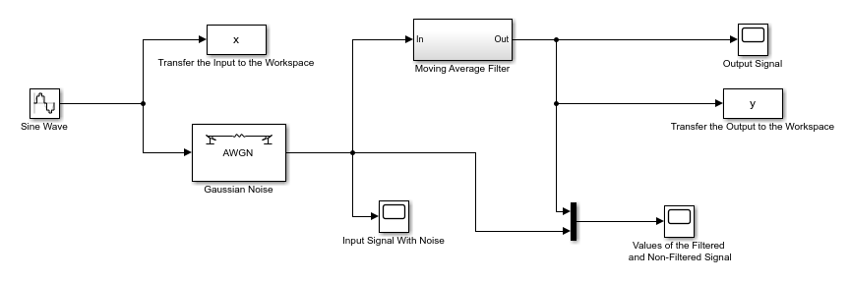

**Simulating a Moving Average Filter**

***YILDIZ TECHNICAL UNIVERSITY | MECHATRONICS ENGINEERING***

R.A. Ahmet Taha KORU | MKT4181 Signal Processing

Anıl ÖZTÜRK | Project 1

1. The accumulator system gives us the summation of all terms until the (n)th term. If we want to get only (n)th term, we must subtract the (n-1)th term from the (n)th term.

The accumulator system can be represented as;

$$y\left[n\right]=\sum_{k=-∞}^{n}{x[k]}$$

If we split the last summarized term seperately, we will get;

$$y\left[n\right]=x\left[n\right]+\sum_{k=-∞}^{n-1}{x[k]}$$

If we want to get the summation until the (n-1)th term, the formula will be;

$$y\left[n-1\right]=\sum_{k=-∞}^{n-1}{x[k]}$$

With these equations, we can get the difference equation as follows;

$$y\left[n\right]=x\left[n\right]+y[n-1]$$

1. We can model the accumulator system with a sample delay as below;

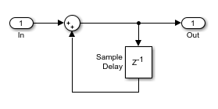

1. Then we can create our Moving Average filter with gain, sample delay and our accumulator sub-system;

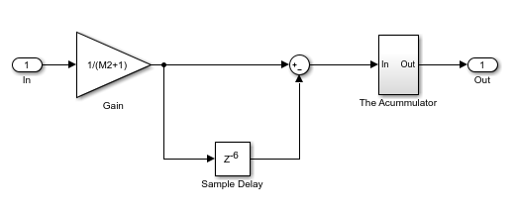

After all these, we will have this whole system to simulate;



1. 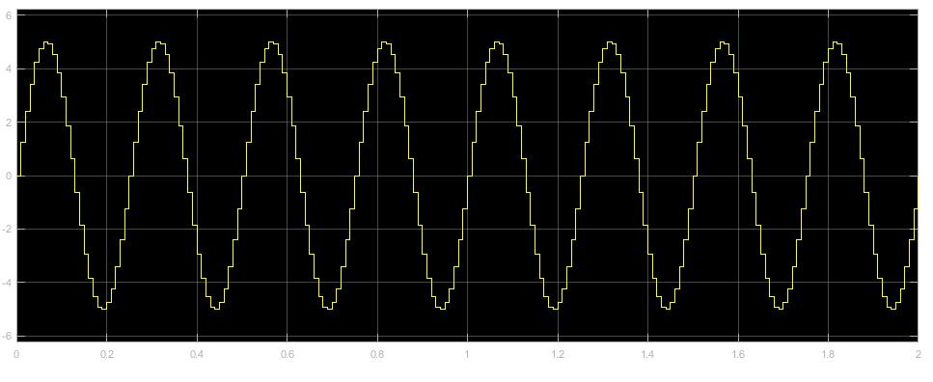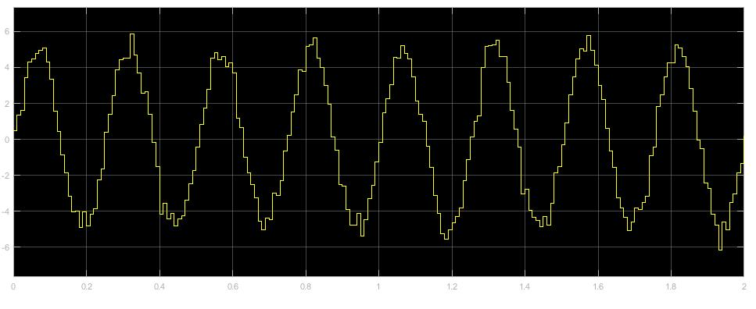If we define $M_{2}=5$, $2π4 rad/sec$ sine wave with a zero mean, $0.2$ variance Gaussian-Noise. We will have these input, noisy input and output signals respectively;
2. 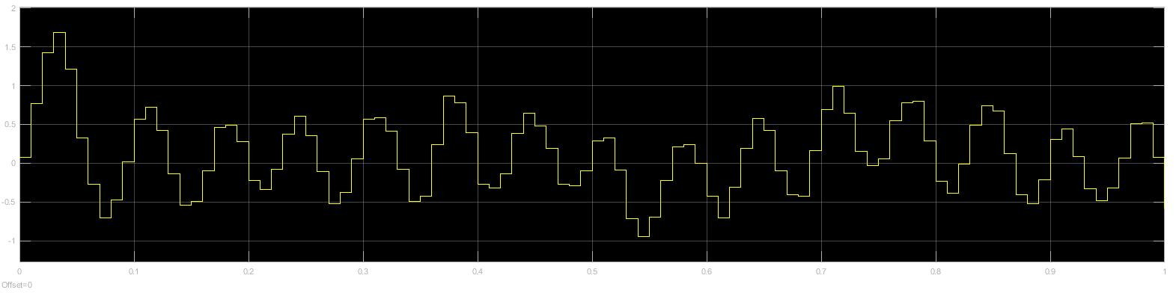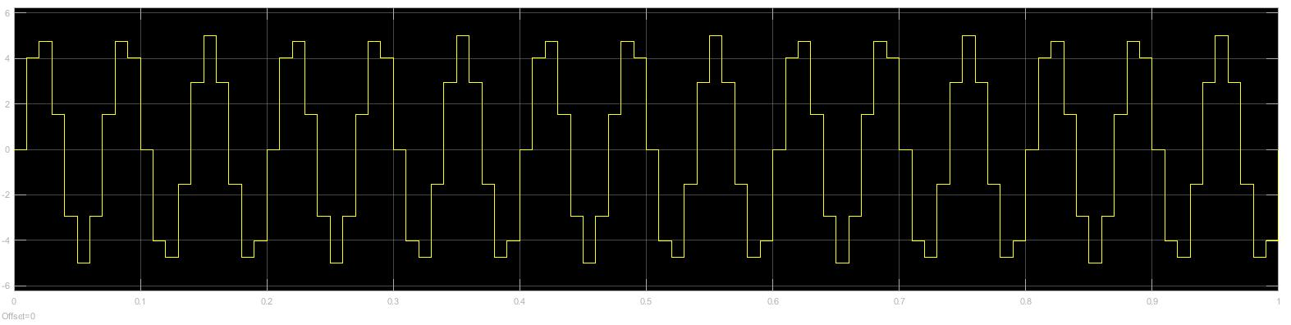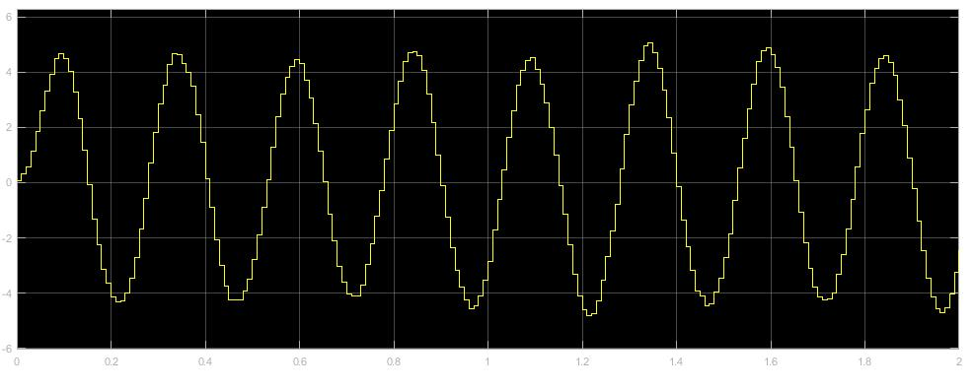 If we define $M_{2}=5$, $2π15 rad/sec$ sine wave with a zero mean, $0.2$ variance Gaussian-Noise. Since the frequency will be too high for 2 second observation, we will change observation time $T=1$. We will have these input, noisy input and output signals respectively;

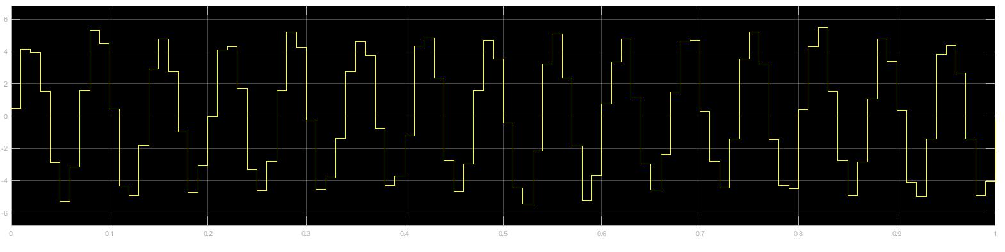

1. In this step, we will analyze the frequency response of the moving average block. We will set the frequency of the sine wave block to a parameter $2πf$. The $f$ parameter is set from workspace of Matlab. We will remove the gaussian noise. We will use “To Workspace” blocks to obtain input and output of the system at Matlab. The system will be like;

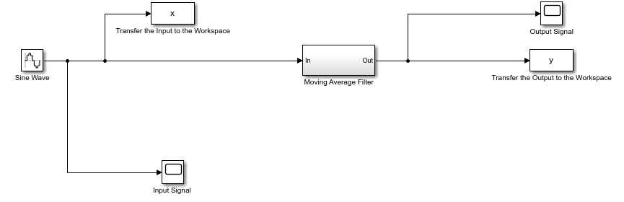

1. Then we will run the simulation for the frequencies between $\left\{1,2…49\right\} Hz$ sinusoidal waves. We will be using following code;

M2=5;

fl = 1:1:49; % Frequency range

for k = 1:length(fl)

f = fl(k); % Sine wave frequency

sim('signal_processing_simulink_hw1'); % The name of the simulink file

Av(k) = max(abs(y))/max(abs(x)); %Filter gain

end

plot(fl, Av)

We must set our frequency from sine wave block in Simulink diagram to $2 x pi x f$. Then we must remove our noise block’s connections with our system. Finally we can observe our frequence-gain graph as below;

